**PROJECT:**

**CAR RENTAL SERVICE**

**Use Case Diagram Of Project:**

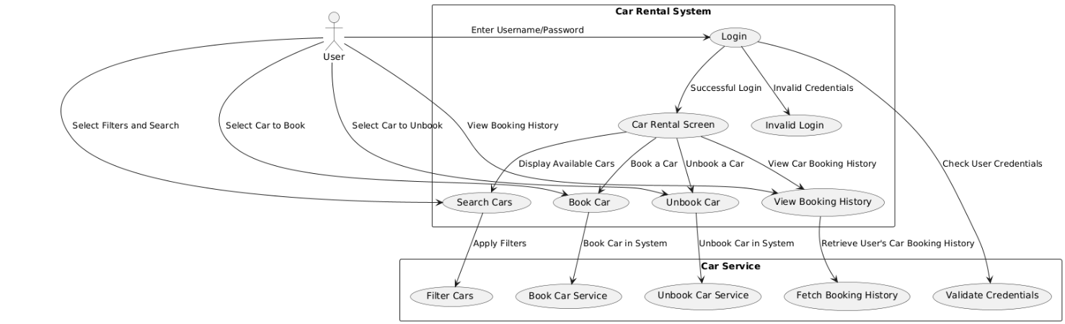

**My Selected Use Case:**

**Search Car:**

Use Case Diagram:

Sequence diagram:

DOWN ⏬⬇⤵🔽

State Machine Diagram:

Class Diagram:

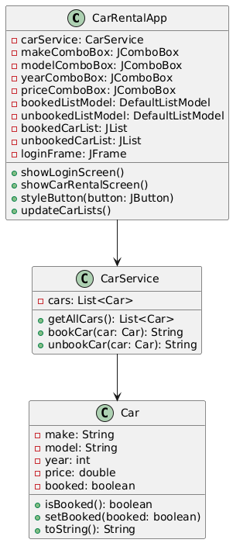

These are the Diagram for my Selected use case.

Search By Model,

Search By Year,

Search By Type,

Search By Brand.

**Fully Dressed Use Case:**

**Search Cars by Type, Model, Year, and Brand**

**Use Case Name:**

Search Cars by Type, Model, Year, and Brand

**Actors:**

* **Primary Actor**: Customer (User)
* **Secondary Actor**: Car Rental System

**Stakeholders and Interests:**

* **Customer**: Wants to efficiently search for cars based on specific preferences (e.g., brand, model, year, type) to find the best car for their rental needs.
* **Car Rental System**: Ensures that the search functionality works smoothly and accurately filters cars based on the user’s input.

**Preconditions:**

1. The customer has logged into the system using valid credentials.
2. The customer is on the "Car Rental" screen and has access to the search filters for car selection.
3. The car list has been populated with available cars (both booked and unbooked) from the database.

**Postconditions:**

1. The system displays a list of cars that match the search criteria based on the selected filters.
2. The displayed list is dynamically updated, showing only cars that match the selected type, model, year, and brand.
3. The car list is updated in real-time, reflecting the changes as the user selects different filter options.

**Main Success Scenario (Basic Flow):**

1. **Login**: The customer logs into the system with valid credentials (username and password).
2. **Navigate to Car Rental Screen**: After a successful login, the customer is directed to the car rental screen, where they can access the car search filters.
3. **Select Search Filters**:
   * The customer selects search filters from the following options:
     + **Type**: (e.g., Sedan, SUV, Truck, etc.)
     + **Model**: (e.g., Camry, Civic, Focus, etc.)
     + **Year**: (e.g., 2017, 2018, 2019, etc.)
     + **Brand**: (e.g., Toyota, Honda, Ford, etc.)
   * Each of these filters is represented as a **JComboBox** (dropdown) in the user interface.
4. **Click Search**: The customer clicks the "Search Cars" button to apply the selected filters.
5. **System Filters and Updates List**:
   * The system checks the available cars in the system.
   * It filters the cars based on the selected filters (type, model, year, and brand).
   * The system updates the list of cars displayed to the customer, showing only those that match the selected criteria.
6. **Display Filtered Cars**:
   * The system displays a dynamically updated list of cars that match the selected filters.
   * The available cars are shown, and the customer can further interact with the list (e.g., selecting cars for booking).
7. **Confirmation of Search**: The system shows a message (optional) indicating how many cars matched the search criteria, or displays "No cars available for the selected filters" if no matches are found.

**Alternative Flows:**

* **A1: No Cars Match the Filter**:
  1. The customer applies filters that do not match any cars in the system (e.g., selecting a year that no car is available in).
  2. The system displays a message: "No cars available for the selected criteria. Please adjust the filters."
  3. The customer can adjust the filters and search again.
* **A2: Clear Filters**:
  1. If the customer wants to clear the selected filters and start a new search, they can click the "Clear Filters" button.
  2. The system resets the filters to their default values (e.g., "Any" for type, model, year, and brand), and the car list is reset to show all cars.

**Exceptions:**

* **E1: Invalid Filter Selection**:
  1. If the customer selects a filter that is invalid (e.g., a non-existent model or year), the system will show a message: "Invalid filter selection. Please try again."
* **E2: System Error**:
  1. If the system encounters an error (e.g., network failure, database issue), it displays a message: "An error occurred while fetching the car list. Please try again later."

**Special Requirements:**

1. The system must allow for dynamic filtering, meaning the search results should update immediately after the "Search Cars" button is clicked, showing only matching cars.
2. The search operation must be quick, and the results should appear within 2-3 seconds.
3. The system should ensure that only valid filter values are accepted (e.g., only valid years, models, and brands).
4. The interface should allow the user to easily reset or clear all selected filters.

**Frequency of Use:**

* This use case is executed each time a customer wants to search for cars based on their preferences (brand, model, year, type).

**Assumptions:**

1. The customer knows how to interact with the search filters and knows the specific type, model, year, and brand of the cars they are interested in.
2. The system is populated with a list of cars that are available for rental, including their respective details (type, model, year, brand).
3. The customer has valid login credentials to access the car rental system.

**Business Rules:**

1. The system should allow multiple search filters to be applied simultaneously (e.g., customer can search for a 2020 Honda Civic SUV).
2. Cars that match all the selected filters should be displayed. If no cars match, the system should show a message prompting the user to adjust the search criteria.
3. The system should show all available cars by default if no filters are applied.

**Use Case: Reset Filters**

**Use Case ID:**

UC-04

**Use Case Name:**

Reset Filters

**Actors:**

* **Primary Actor**: Customer (User)

**Preconditions:**

1. The customer is on the car rental screen with the search filters set to certain values.

**Postconditions:**

1. The search filters are reset to their default values (e.g., "Any" for type, model, year, and brand).
2. The car list is updated to show all available cars.

**Main Success Scenario (Basic Flow):**

1. **Click Reset**: The customer clicks the "Reset Filters" button.
2. **System Resets Filters**: The system resets the filters to default values ("Any").
3. **Car List Update**: The system updates the car list to show all available cars.

**PACKAGE DIAGRAM:**

